TEAM-3

CAMPUS EVENT HUB



Submitted by:

Project Title

CampusEventHub – Inter-College Event Management Platform. This project provides a centralized and digital approach for organizing and managing events across multiple colleges. It integrates user-friendly interfaces for both students and administrators while ensuring secure access, role-based functionality, and efficient event handling. The platform eliminates the limitations of traditional event management by offering a structured, scalable, and user-centric solution.

CampusEventHub is designed as a web-based event management system to address the challenges of traditional event organization in academic institutions. By automating registration, event creation, and listings, it eliminates manual paperwork and communication gaps. The system is aimed at improving the experience of both college administrators and students. Key objectives include creating a centralized hub for event listings, enabling admins to efficiently manage events, and offering students a seamless portal for event discovery and participation. By Milestone 2, the system ensures smooth authentication,
role-based access, event creation, and event listing functionalities.

Events such as cultural fests, hackathons, workshops, and sports meets play a crucial role in fostering creativity, collaboration, and skill development among students. However, managing these events manually often leads to challenges such as delayed communication, difficulty in tracking registrations, inefficient resource allocation, and lack of transparency. CampusEventHub addresses these issues by providing a centralized digital platform with secure user authentication, role-based dashboards, and event creation forms for admins, ensuring efficient event management and smooth coordination.
For students, the system offers event listings with filtering options by category, date, or college, simplifying the process of finding and registering for events. Built on the MERN stack (MongoDB, Express.js, React.js, Node.js), CampusEventHub ensures scalability, security, and modern web practices, with a responsive and user-friendly interface. Notifications, alerts, and structured navigation enhance engagement and transparency, making the platform a reliable solution for managing campus events effectively.

1. User Authentication and Registration
- Secure registration and login for students and admins with unique credentials.
- Password recovery and email verification for user security.
2. Role-Based Dashboards
- Admin dashboard to manage events and control user access.
- Student dashboard to view events and track participation.
3. Event Creation and Management
- Admins can create events with title, description, venue, schedule, and category.
- Option to edit or delete events and manage event visibility.
4. Event Listing and Filtering
- Students can view events in list or calendar view.
- Filter and search events by category, date, or college.
5. Data Storage and Retrieval
- Persistent storage of event and user data in the database.
- Efficient retrieval of events for dashboards and listings.
6. Event Registration and Participation
- Students can register for events and receive confirmation.
- Admins can track participant lists for each event.
7. Notifications and Alerts
- Real-time notifications for new or updated events.
- Reminders for registered events and admin alerts.
8. Reporting and Analytics
- Admins can generate reports on event participation.
- View trends to improve future event planning and engagement

1. Performance
- System should load event listings and other pages quickly, even with large datasets.
- Efficient querying and data fetching to reduce response time.
2. Scalability
- Able to handle growing number of users, including multiple colleges and student groups.
- Supports horizontal scaling by adding servers or cloud resources as user load increases.
3. Usability
- Provides a clean and intuitive interface for all users.
- Responsive design ensures accessibility on desktops, tablets, and mobile devices.
4. Security
- User passwords are stored securely using hashing and salting techniques.
- Implements JWT (JSON Web Token) authentication for secure session management.
5. Maintainability
- Code is organized into modular, reusable components for easier updates and debugging.
- System documentation and comments facilitate future maintenance and feature upgrades.
6. Reliability & Availability
- System is designed to minimize downtime and ensure continuous availability.
- Implements backup and recovery mechanisms to prevent data loss.
7. Compatibility
- Compatible with all modern browsers (Chrome, Firefox, Edge, Safari).
- Supports different operating systems including Windows, macOS, and Linux.
8. Extensibility
- Designed to allow easy addition of new features without major changes to existing code.
- Provides well-documented APIs for external integrations.

1. User Login and Registration
- Secure registration and login system with proper validation.
- Password recovery and email verification for enhanced security.
2. Role-Based Dashboards
- Separate dashboards for Admin and Student with tailored functionalities.
- Admin can manage events, while students can view and register for events.
3. Event Creation
- Event creation form with fields for title, description, venue, schedule, and category.
- Proper validation to ensure all required information is entered correctly.
4. Event Listing and Filtering
- Students can view events in a structured list or calendar format.
- Filter events by category, date, or college for easier access.
5. Secure Authentication
- JWT-based authentication to secure all user sessions.
- Role-based access control to restrict access to authorized functionalities.
6. Platform Navigation
- Structured navigation menus for easy access to all sections.
- Responsive design ensures usability across devices.
.

Three-Tier Architecture:
- Presentation Layer (React.js): The user interface for students and admins, handling forms, navigation, and API calls.
- Application Layer (Node.js + Express): Contains business logic, authentication, and API endpoints.
- Data Layer (MongoDB/MySQL): Stores all data like users, events, and roles.

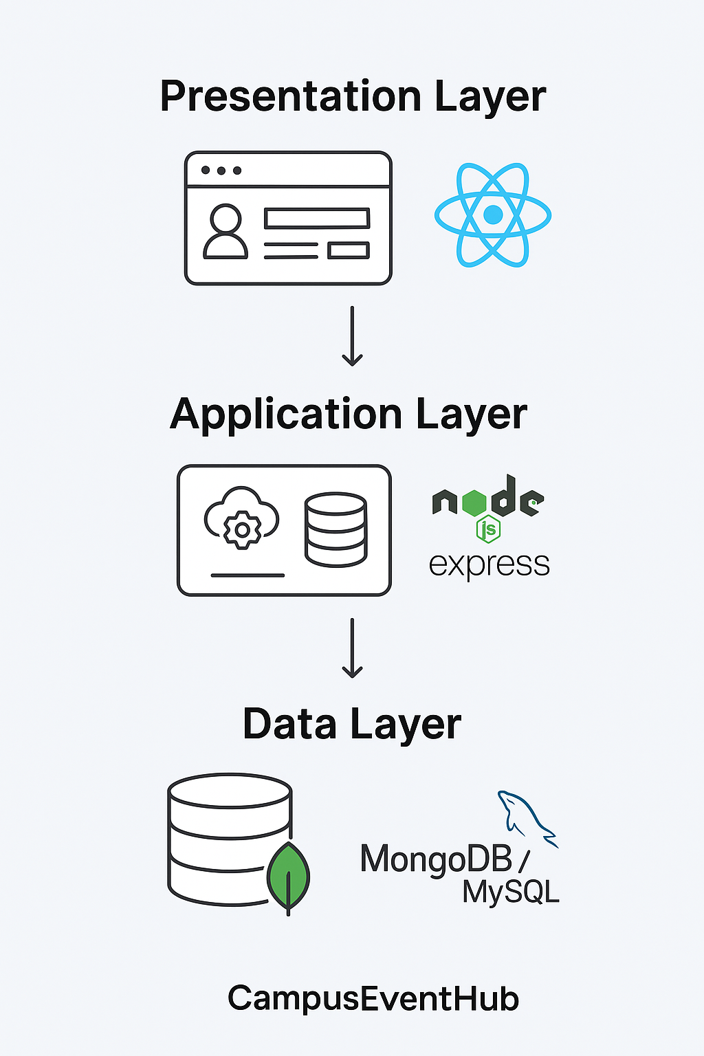

Users Table
- Stores user info: name, email, password, college, role.
- id = primary key (unique for each user).
Events Table
- Stores event details: title, description, category, location, dates.
- college_id links event to a college/organizer.
- id = primary key.
Registrations Table
- Tracks which user registered for which event.
- Fields: status (registered/canceled), timestamp.
- event_id → Events, user_id → Users.
- Resolves many-to-many relation between Users & Events.
Feedback Table
- Stores ratings and comments given by users.
- event_id → Events, user_id → Users.
- Each feedback belongs to one event and one user.

Relationships
- One user → many registrations.
- One event → many registrations.
- One user → many feedbacks.
- One event → many feedbacks.

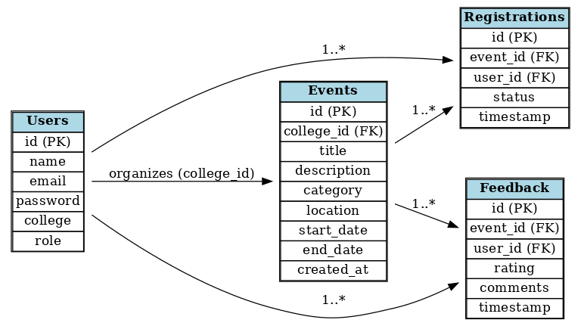

Home.jsx

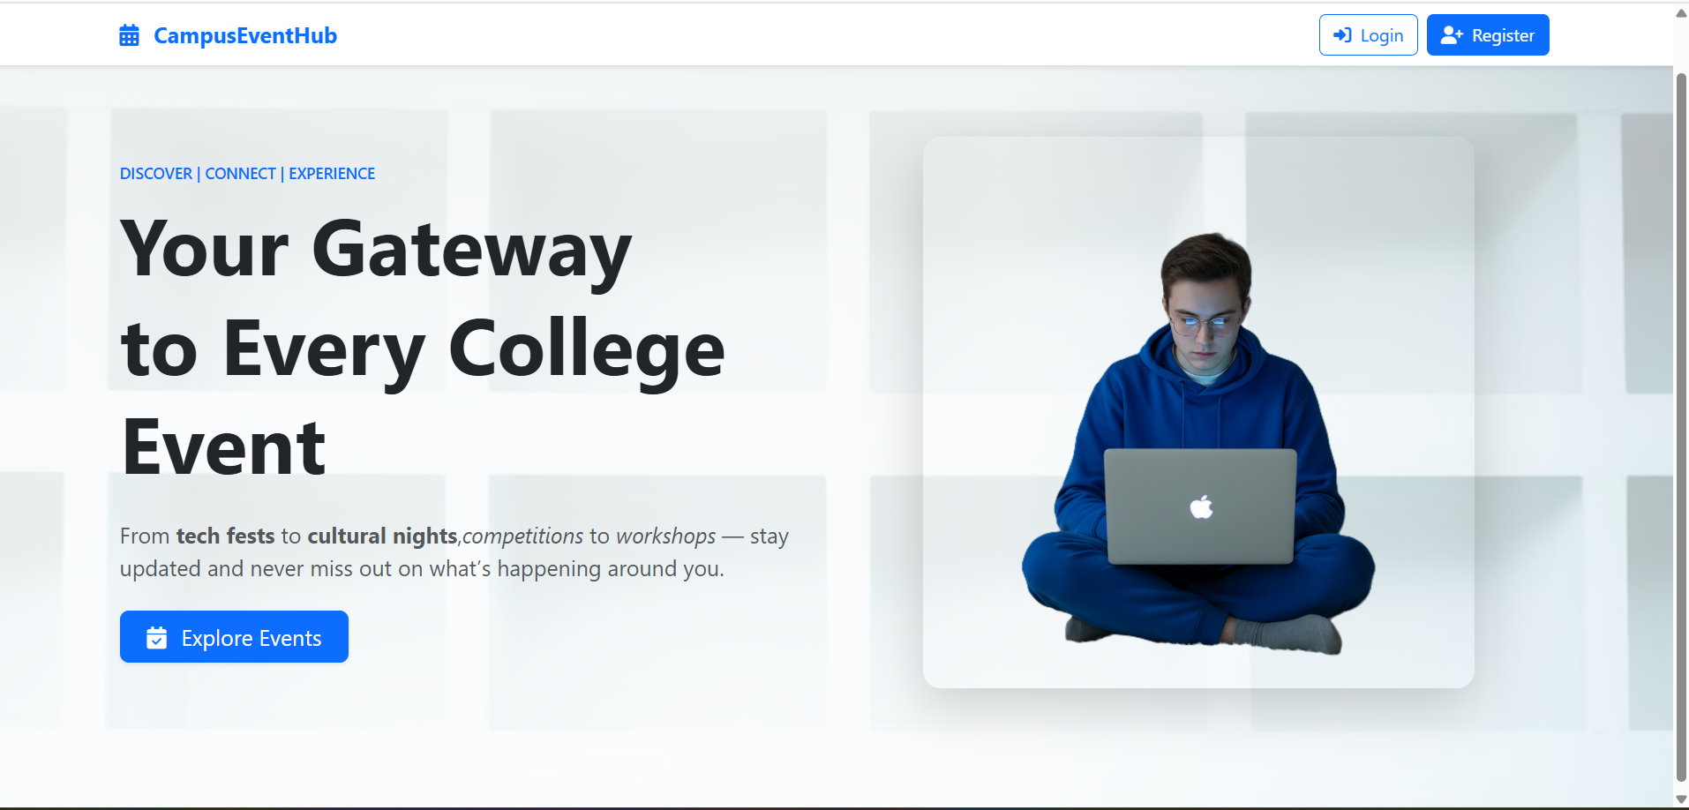

Register.jsx

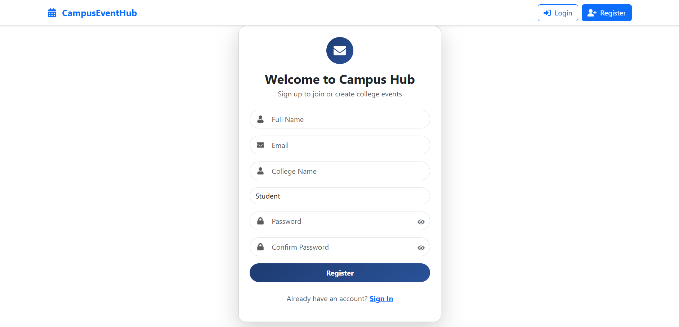

Login.jsx:

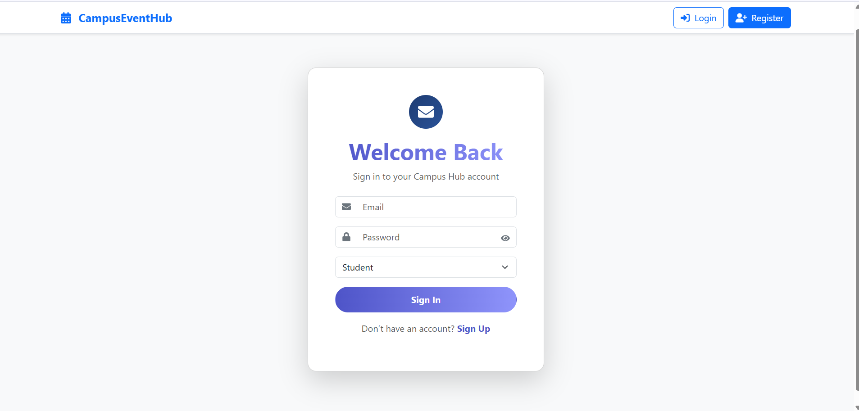

UserDashboard.js

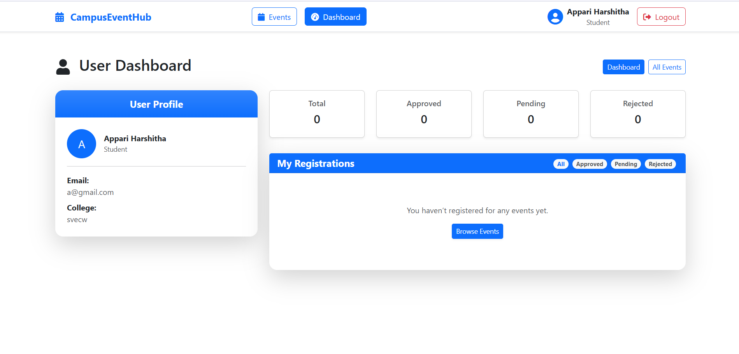

Events.jsx

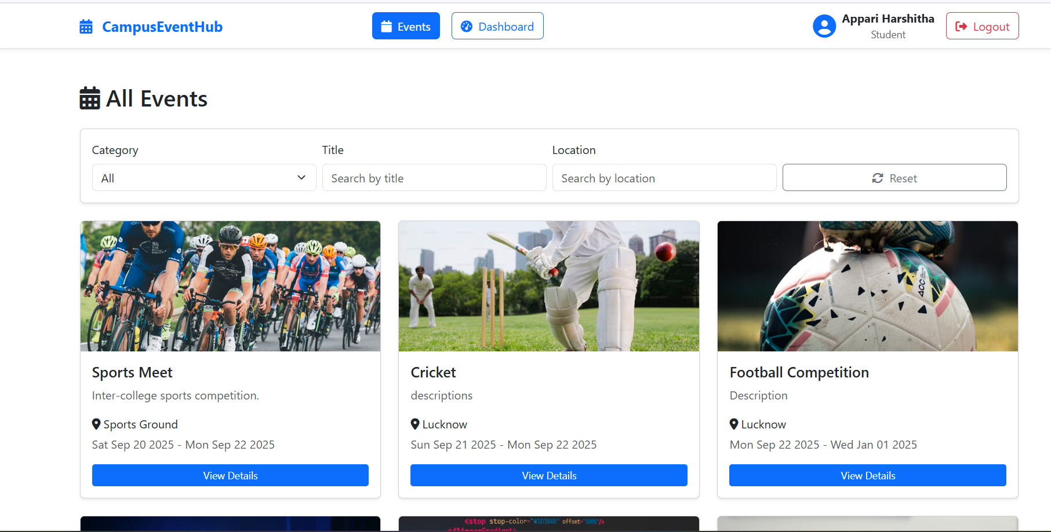

- Implementing secure login using JWT and managing role-based access (student, organizer, admin).
- Creating a responsive and user-friendly interface that works on all devices.
- Building the event filtering logic to handle multiple parameters like category, date, and location.
- Designing proper database relationships between users, events, and registrations.
- Ensuring smooth communication between frontend and backend using REST APIs.

By the end of Milestone 2, CampusEventHub has basic features working such as user login with authentication, role-based dashboards, event creation, and event listing. These features form a strong base for adding the next parts like registrations, participant management, and feedback. The project makes event management easier by moving it online and also helps colleges and students connect and work together in a clear and scalable way.

